How to generate getters/setters

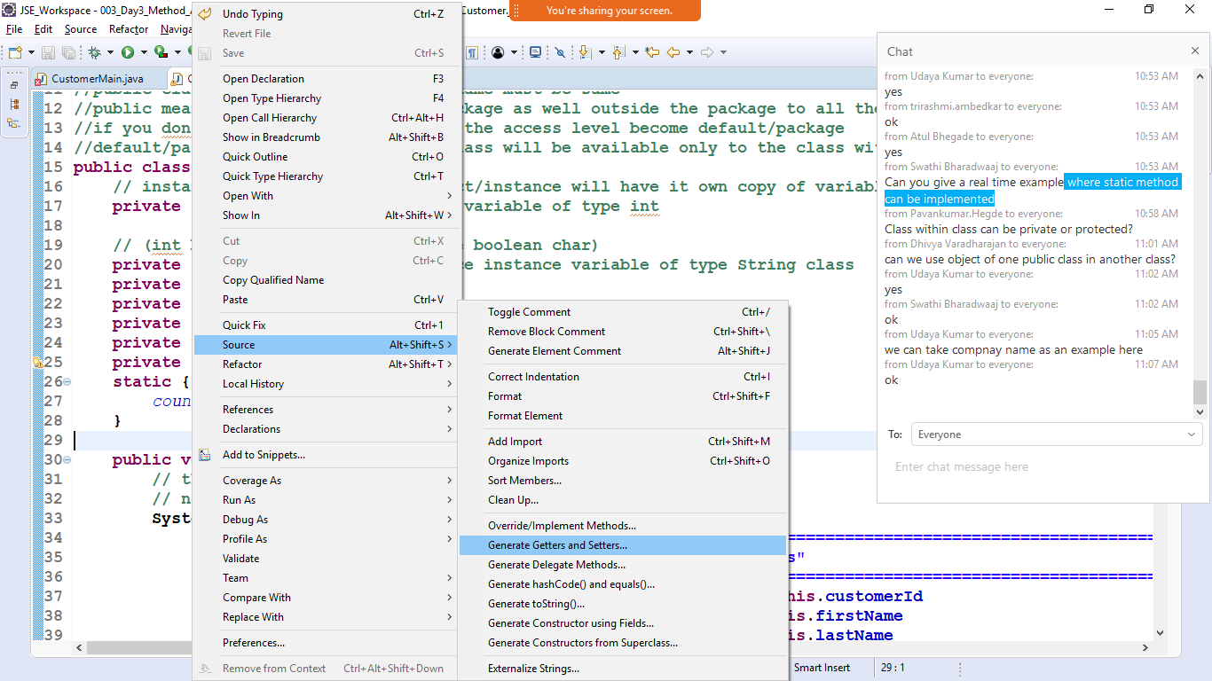

Right click inside class body -> Source ->generate getters ans setters

Select the properties

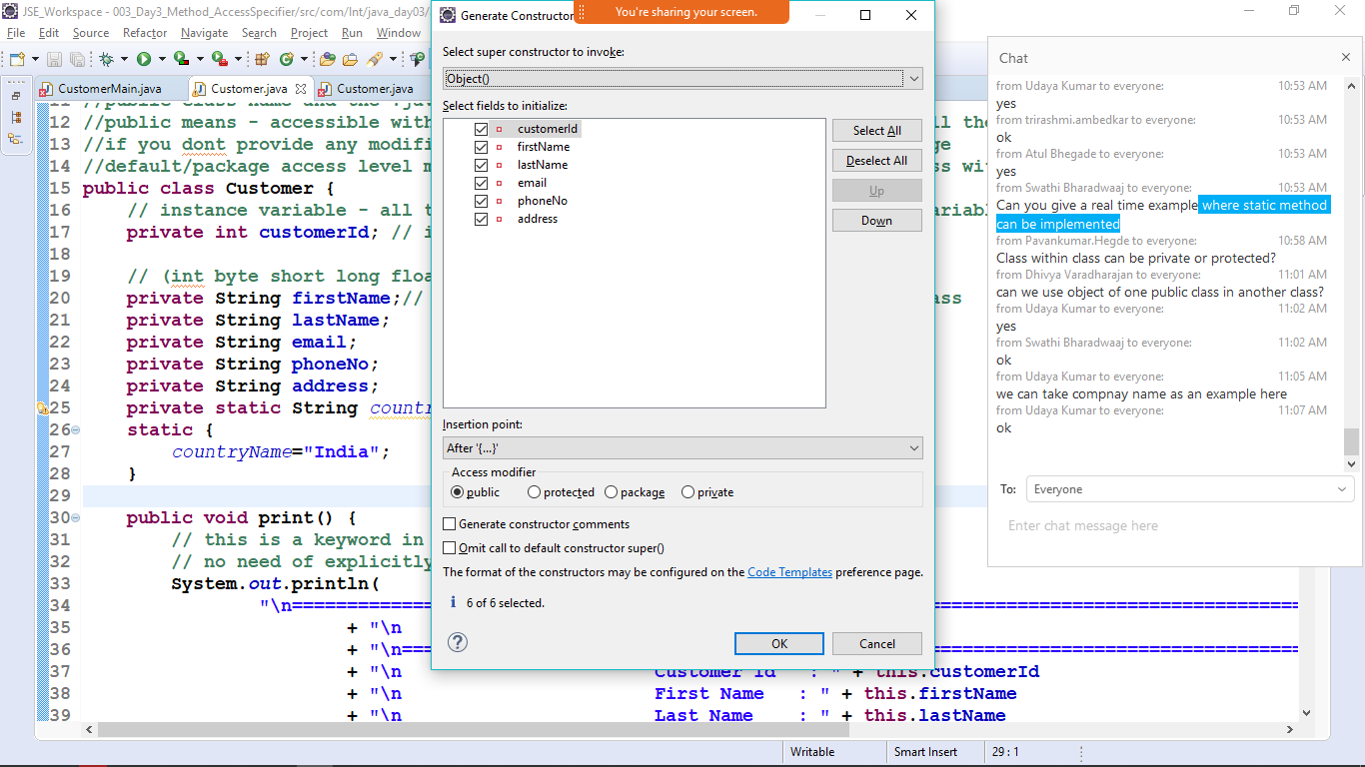

Ok